Q1. How did you decide the Low and high thresholds for hysteresis? What were your observations?

Ans: I choose low and high thresholds to be 0.3 and 0.8, respectively. I choose these values as they provide better SSIM and PSNR values. If I reduce the threshold values, there is more noise in edge image created from myCannyEdgeDetector() function. But if I choose higher value, it impacts the SSIM value.

Q2. Method in CollageCreate(), how are the images joined together?

Ans: Image 2 and Image 5 are at the centre because of less colour variation and Image 1, 3, 4 and 6 are the corners because of more colour variation. As we can see from below histograms.

To join images, I have used two different methods (one without overlay and with overlay):

1. First, I have used vstack and hstack to join all the 6 images. In this image with less colour variation has been placed in centre. This way initially collage without overlay is created.
2. To create an overlay collage, I have extracted the areas that needs to overlay from each image and add their respective matrix with the adjacent matrix of next image.
3. Finally, I replaced the overlay part with this new matrix created in step 2.

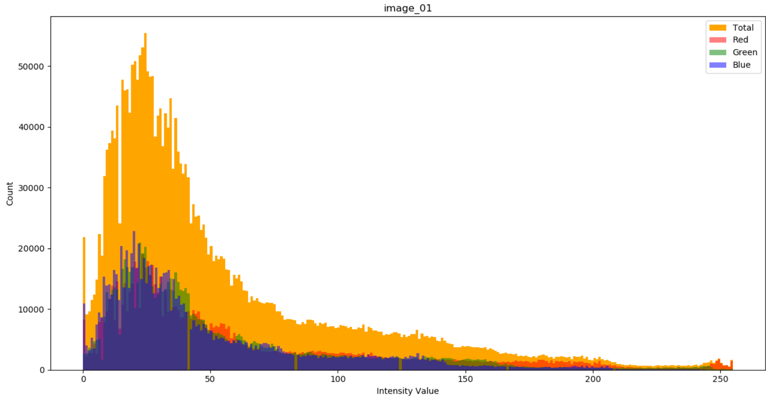

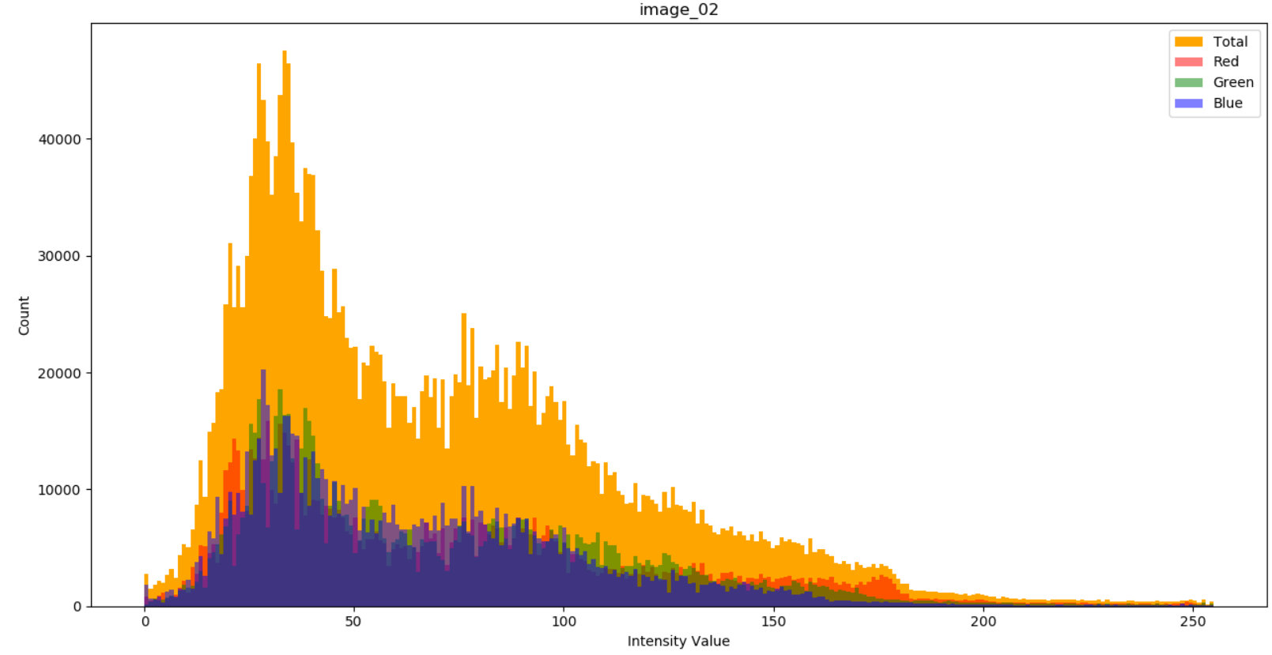

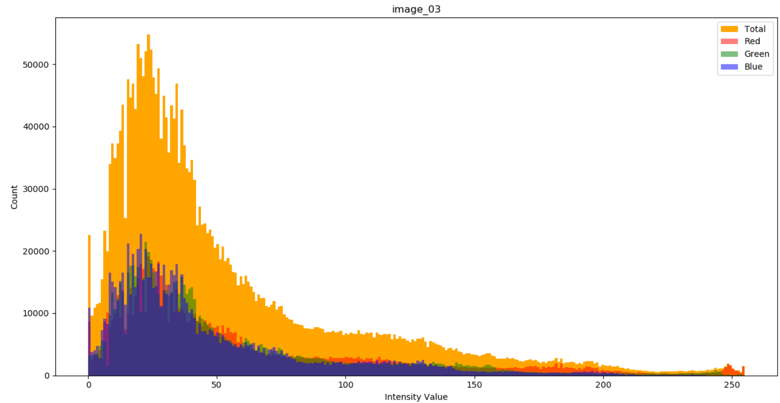

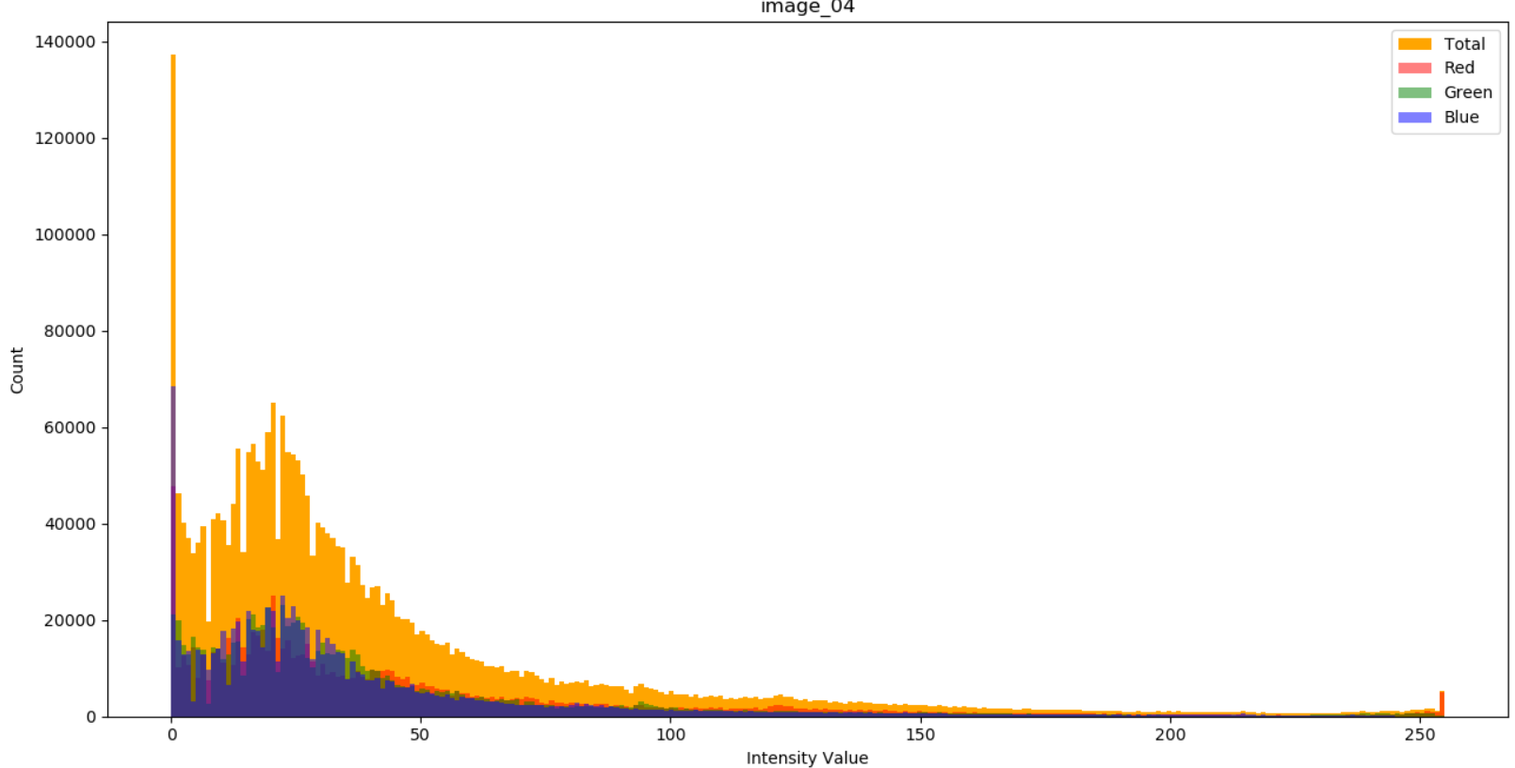

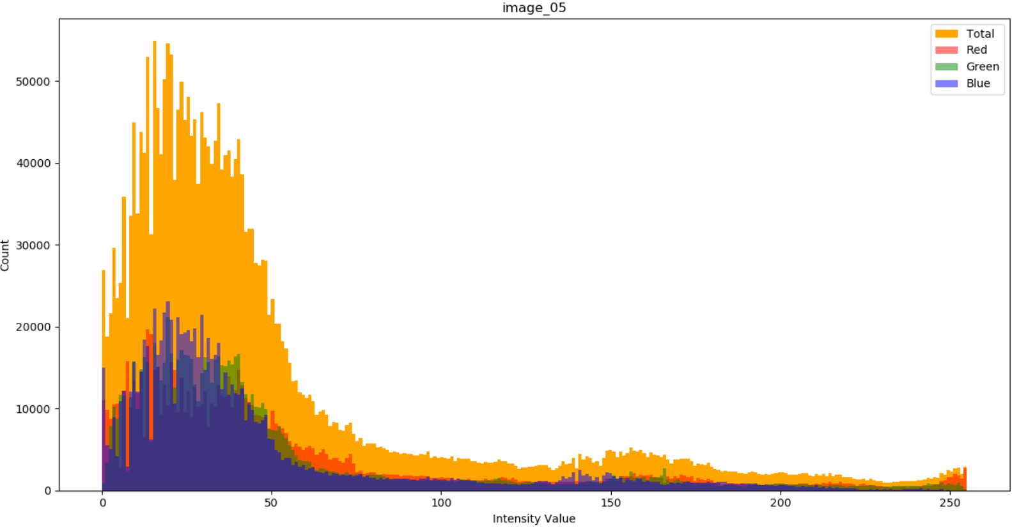

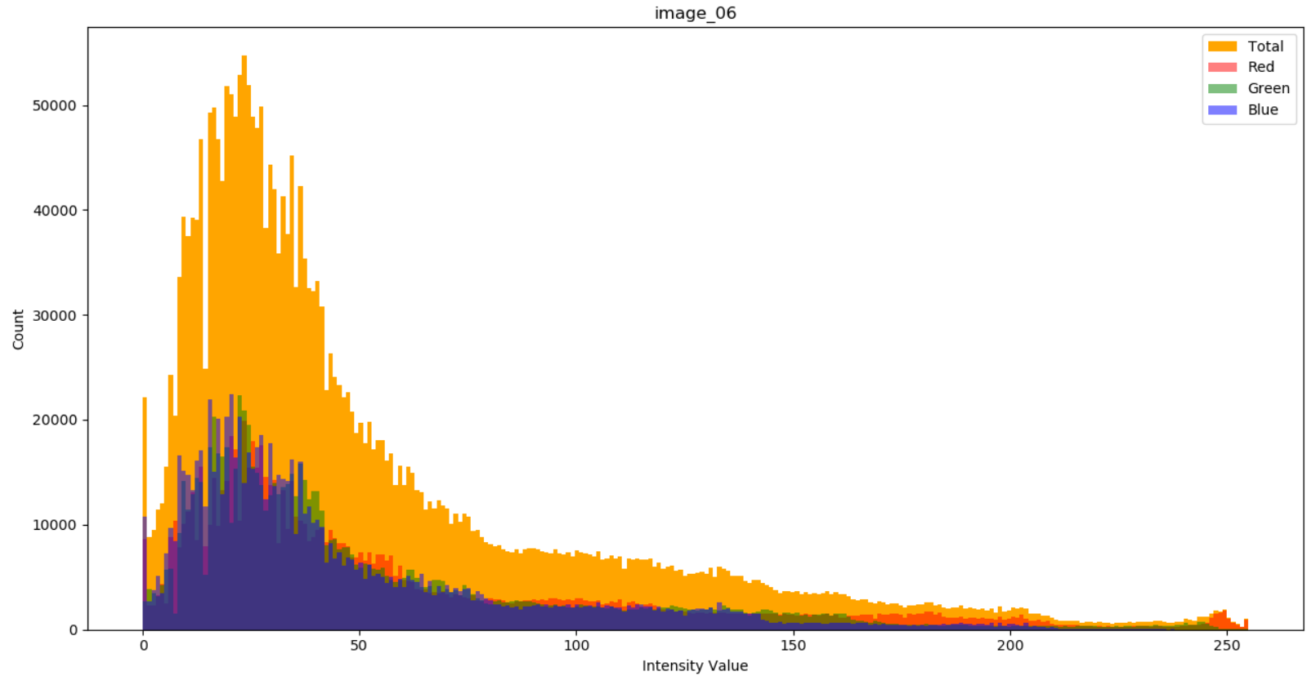

Extra: Command to extract images or frame from a video:

**ffmpeg -i Video.mp4 -r 1 image_%01d.png**